Coversheet
The Coversheet must contain the following:
- Heading “Electrical System Form FSN 2022”
- University and Team Name
- Car number
Feel free to add team logo, car picture, and the like.

- Requirements (delete this section after you have read and understood it):
- Complete all sections and tables of the ESF. If a section is not applicable to your design state that in the document, do not delete any sections.
- Remove instructions (orange) from document as you complete the sections.
- Provide hyperlinks to all datasheets.
- If you are unsure with respect to feedback of the reviewer, do not hesitate to ask the Lead E-scruti via E-mail
- Parts of the ESF which are changed because of reviewer’s feedback must be marked in red.
- Following these guidelines will guarantee a swift review process.

Table of Contents
1 System Overview 7
2 Tractive System Schematics 7
2.1 Tractive System Schematic (Power Electronics ONLY) 7
2.2 Fusing Diagram 8
3 Shutdown Circuit 9
3.1 Shutdown Circuit Schematic 9
3.2 Wiring 10
3.3 IMD 10
3.4 Brake System Plausibility Device 11
3.5 Battery Management System 12
4 Safety Systems 13
4.1 TSAL 13
4.2 Measurement Points 14
4.3 HVD 15
4.4 Ready to Drive Sound 16
4.5 Discharge Circuit 16
5 Accumulator 17
5.1 Accumulator Schematic 17
5.2 Cells 18
5.3 Segments 20
5.4 Precharge Circuit 21
5.5 BMS 22
5.6 AIR 23
5.7 Accumulator Indicator 23
5.8 Mechanical 24
5.9 Charging 24
6 Motor controller 26
6.1 Motor controller 1 26
6.2 Motor controller 2 27
7 Motors 28
7.1 Motor 1 28
7.2 Motor 2 29
8 Torque encoder 30
8.1 Description/additional circuitry 30
8.2 Wiring 30
8.3 Position in car/mechanical fastening/mechanical connection 30
9 Other Items 30
9.1 Energy Meter 30
9.2 Firewall 31
9.3 Grounding 32
9.4 Other Components 32
10 Appendix 32
10.1 SDS (MSDS) of accumulator cell 32

Table of Figures
Figure 1-1 - System Block Diagram 7
Figure 2-1 - HV System Schematic 8
Figure 3-1 - Shutdown Circuit Schematic 10
Figure 3-2 - Shutdown Circuit Switch Locations 10
Figure 3-3 - IMD Latch Circuit Schematic 11
Figure 3-4 - BSPD Schematic 12
Figure 3-5 - BSPD Component Location 13
Figure 4-1 - TSAL Circuit Schematic 14
Figure 4-3 - TSAL Component Locations 14
Figure 4-4 - Measurement Point Location 15
Figure 4-5 - TSMP Protection Resistor Location 16
Figure 4-6 - HVD Location 17
Figure 4-7 - Discharge Circuit Component Locations 18
Figure 5-1 - Accumulator Schematic 20
Figure 5-1 - Cell Connection Detail 21
Figure 5-1 - Cell Mounting in Accumulator 22
Figure 5-2 - Maintenance Plug Locations 23
Figure 5-3 - Precharge Circuit Location 24
Figure 5-4 - Location of Temperature Sensors 25
Figure 5-5 - BMS Location 26
Figure 5-6 - Schematic of Accumulator Indication 26
Figure 5-7 - AIR and Fuse Separation 27
Figure 5-8 - Chrarging Shutdown Circuit Schematic 28
Figure 5-9 - Charging TS Schematic 28
Figure 6-1 - Toque Control Signal Path 29
Figure 7-1 - Energy Meter Location 29
Figure 7-2 - Firewall Location 30

Table of Tables
Table 1-1 - High Level Specifications 7
Table 2-1- Fuse Tree Diagram 8
Table 2-2 - Fuse Specifications 9
Table 2-3 - Conductor Specifications 9
Table 2-4- Connector Specifications 9
Table 3-2 - Shutdown Circuit Loads 10
Table 3-5 - IMD Specifications 11
Table 3-6 - BSPD Current Sensor Specifications 12
Table 3-7 - BSPD Operation Details 12
Table 4-1 - TSAL Specifications 13
Table 4-2 - Measurement Point Specifications 14
Table 4-3 - TSMP Protection Resistor Specifications 15
Table 4-4 - HVD Specifications 16
Table 4-5 - RTDS Specifications 17
Table 4-6 - Discharge Resistor Specifications 18
Table 4-7 - Discharge Relay Specifications 18
Table 5-1 - Cell Specifications 21
Table 5-2 - Segment Specifications 22
Table 5-3 - Maintenance Plug Connector Specification 22
Table 5-4 - Precharge Resistor Specifications 23
Table 5-5 - Precharge Relay Specifications 23
Table 5-6 - Temperature Sensor Specifications 24
Table 5-7 - BMS Setpoints 25
Table 5-8- AIR Specifications 26
Table 5-9 - Charger Specifications 27
Table 7-1 - Firewall Specifications 30

Abbreviations
AIR – Accumulator Insulation Relay
AMS- Accumulator Monitoring System
BMS- Battery Monitoring System
BOTS – Brake-Over-Travel-Switch
BSPD – Brake System Plausibility Device
GLV – Grounded Low Voltage
GLVMP – Ground Low Voltage Measurement Point
HV – High Voltage
IMD – Insulation Monitoring Device
TS – Tractive System
TSAL – Tractive System Active Light
TSMP – Tractive System Measurement Point

System Overview
Include brief description of vehicle (1 paragraph).

Complete the information in the table below.
Maximum Tractive System Voltage: | 1000VDC
Nominal Tractive System Voltage: | 960VDC
Grounded Low Voltage System Voltage: | 2.5VDC
Number of Accumulator Containers: | 2
Total Accumulator Capacity: | 20kWhr
Motor Type: | AC Induction
Number of Motors: | Total 4, one per wheel
Maximum Combined Motor Power: | 150kW
Table 1-1 - High Level Specifications
Insert a system overview block diagram showing major electrical components and system interactions
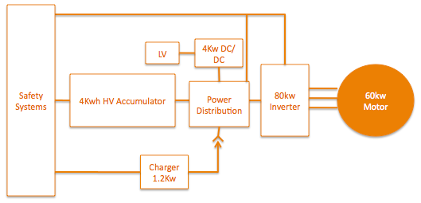
Figure 1-1 - System Block Diagram

Tractive System Schematics

Tractive System Schematic (Power Electronics ONLY)
Insert a large (full page) schematic of the HV system. This schematic should focus on the components that are not within the accumulator. Provide boxes and 1st level interfaces, when details will be provided later in this document. Some detail of components within the accumulator may be included for better understanding (ie AIRs).
Figure must include the following:
- Wire Size (AWG or mm²)
- Relative fuse location (end of wire vs middle)
- Fuse rating (Amperage and Voltage)
- Motor controller (1st level interfaces...inputs & outputs)
- Motor
- Inline connectors and interfaces for charging
- TSMP and relative current limiting resistor locations
- Show enclosures as dashed lines
The figure must include the following if not within the accumulator
- IMD
- DCDC converter if used
- Precharge and Discharge circuit
- Energy Meter
- HVD

Figure 2-1 - HV System Schematic

Fusing Diagram
Include a fusing tree diagram like the one shown below.
Table 2-1- Fuse Tree Diagram

Fuse Specifications
Complete the information in the table below.
Fuse Location | Current Rating | Voltage Rating | Interrupt Rating | Datasheet
Table 2-2 - Fuse Specifications

Conductor Specifications
Complete the information in the table below.
Conductor Location | Size | Voltage Rating | Ampacity | Rating of fuse providing protection | Datasheet
Table 2-3 - Conductor Specifications

Connector Specifications
Complete the information in the table below.
Connector Location | Ampacity | Voltage Rating | Includes Interlock | Accepted wire gauge | Wire gauge connected
Table 2-4- Connector Specifications

Shutdown Circuit

Shutdown Circuit Schematic
Insert a large (full page) schematic of the shutdown circuit.
The schematic must include the following:
- All shutdown circuit switches/devices (indicate Normally Open or Closed)
- Safety interlocks associated to connectors or HVD
- BMS connection to shutdown circuit
- BSPD connection to shutdown circuit
- IMD connection to shutdown circuit (include path from output of IMD OKHS to shutdown circuit, additional detail may be provided in second figure)
- BOTS
- Inertia switch
- AIR coils including resistance of coil and voltage rating or economizer detail
- Pre-charge relay coil
- GLV battery
- Fuse(s)
- Wire Size (AWG or mm²)
Figure 3-1 - Shutdown Circuit Schematic

Switch Locations
Provide CAD-rendering(s) showing the shutdown circuit parts. Mark the parts in the renderings, if necessary. Include your design intent wire harness routing path.
Figure 3-2 - Shutdown Circuit Switch Locations

Wiring

Shutdown Circuit Current
Complete the information in the table below.
Total Number of AIRs: | 10
Current per AIR: | 0.5A
Additional parts consumption within the shutdown circuit: | 2A
Total current: | 7A
Table 3-1 - Shutdown Circuit Loads

IMD

IMD Specifications
Complete the information in the table below.
Make / Model | Bender IR12345
Supply voltage | 2VDC
Environmental temperature range: | 45..55°C
Self-test interval: | every 20 ms
High voltage range: | DC 0..10V
Set response value: | 30kΩ (500Ω/Volt)
Max. operation current: | 500mA
Approximate time to shut down at 50% of the response value: | 80s
Datasheet | Datasheet
Table 3-2 - IMD Specifications

IMD Fault Latching
Include schematic showing how latching circuit for IMD operates. Also include the IMD status indicator in the figure.
Figure 3-3 - IMD Latch Circuit Schematic

IMD Location
Describe the location of the IMD.
Describe the location of the IMD indicator.
Describe the location of the reset button or include a CAD rendering or photograph to show its location.

Brake System Plausibility Device

BSPD Current Sensor
Complete the information in the table below.
Make / Model: | Acme Sensor Co. ABC123
Current input range: | +/- 150A
Output range: | 0-50V
Datasheet: | Datasheet
Table 3-3 - BSPD Current Sensor Specifications

BSPD Setpoint
Complete the information in the table below.
Trip Current | 62A
Current sensor output @Trip Current | 35V
Delay time | 200ms
Table 3-4 - BSPD Operation Details

BSPD Schematic
Include schematic of BSPD. Clearly show current sensor input, brake input and shutdown circuit output. Be sure schematic includes details addressing latching and timing.
Figure 3-4 - BSPD Schematic

BSPD Location
Describe the location of the BSPD and reset button or include a CAD rendering or photograph to show its location.
Figure 3-5 - BSPD Component Location

BSPD Demonstration
Describe the method you will use to demonstrate the BSPD device at competition.

Battery Management System

BMS Faults
Describe what faults/conditions will cause the BMS to open the shutdown circuit.

BMS Fault Latching
Describe the method used to latch the BMS fault, include a schematic if appropriate.
- Describe the location of the reset button or include a CAD rendering or photograph to show its location.

Safety Systems

TSAL

TSAL Specifications
Complete the information in the table below.
Make/Model: | Flashy Light Co. SprBrt12
Color: | Purple
Flash Rate: | 18Hz
Powered By: | GLV
Controlled By: | TS
TS Turn On Voltage: | 60
TS Turn Off Voltage: | 58
Table 4-1 - TSAL Specifications

TSAL Schematic
Include a schematic showing the control circuit for the TSAL. The schematic should include all components from HV sense input to light. If team designed PCB is used with TS and GLV circuits provide CAD rendering or photograph showing spacing for TS/GLV separation.
Figure 4-1 - TSAL Circuit Schematic

TSAL Location
Provide CAD-rendering(s) showing the TSAL parts. Mark the parts in the renderings, if necessary.
Figure 4-2 - TSAL Component Locations

TSAL Demonstration
How will you proof the correct functionality of the TSAL during Scrutineering?

Measurement Points

Measurement Point Specifications
Complete the information in the table below.
Make / Model: | Acme Connect Co P88943
Voltage Rating: | 600V
Datasheet: | Datasheet
Table 4-2 - Measurement Point Specifications

Measurement Point Location
Provide CAD-rendering(s) showing the measurement points. Mark the parts in the renderings, if necessary.
Figure 4-3 - Measurement Point Location

Measurement Point Protection
Describe how the backs of the TSMPs are protected from being touched.
Describe how the fronts of the TSMPs are protected from rain entering and how the cover is removed for testing.

TSMP Protection Resistor
Complete the information in the table below.
Make / Model: | ResistorsRUs R10K5W
Resistance: | 10,000Ω
Voltage Rating: | 1000V
Power Rating: | 5W
Datasheet: | Datasheet
Table 4-3 - TSMP Protection Resistor Specifications

TSMP Protection Resistor Location
Provide CAD-rendering(s) showing the measurement point protection resistor location. Mark the parts in the renderings, if necessary.
Figure 4-4 - TSMP Protection Resistor Location

HVD

HVD Specifications
Complete the information in the table below.
Make / Model: | Best HVD Company HVD111
Ampacity: | 45A
Voltage rating: | 1000V
Datasheet: | Datasheet
Table 4-4 - HVD Specifications
If the HVD is not an “off the shelf design” describe how it works and include a CAD rendering.
Which contacts make/break first (high current or interlock)?

HVD Location
Provide CAD-rendering(s) showing the HVD. Mark the parts in the renderings, if necessary.
Describe the physical distance (cm) from the road surface to the bottom of the HVD.
Figure 4-5 - HVD Location

HVD Connections
Describe how the electrical connections are made to the HVD. How are these protected from rain and touch?

Ready to Drive Sound

RTDS Device and Control
Describe how the RTDS is controlled (what device controls it). Complete the information in the table below.
Make / Model: | Loud Alerts 12VBzr95
Control Voltage: | 14V
SPL at 2m: | 86 dBA
Datasheet: | Datasheet
Table 4-5 - RTDS Specifications

Ready to Drive Mode Demonstration
Describe numbered steps required to put the vehicle into ready to drive mode.

Discharge Circuit

Discharge Circuit Concept
Describe your discharge circuit and how it is controlled.

Discharge Circuit Component Specifications
Complete the information in the tables below.
Make / Model: | ResistorsRUs 500R10W
Resistance: | 500Ω
Voltage: | 800V
Power: | 10W
Power @15sec: | 80W
Datasheet | Datasheet
Table 4-6 - Discharge Resistor Specifications
Make / Model: | RelayCo ABCD876
Contact Current Rating: | 1A
Contact Voltage Rating: | 750V
Datasheet: | Datasheet
Table 4-7 - Discharge Relay Specifications
What is the capacitance of the TS bus (include DCDC converter if part of design)? How long does it take to discharge to <60V?

If semiconductor elements are used include schematics and provide datasheets of the most relevant components.

Discharge Circuit Location
Describe location or provide CAD-rendering(s) or photographs showing the discharge components. Mark the parts in the renderings, if necessary.
Figure 4-6 - Discharge Circuit Component Locations

Discharge Circuit Control
Describe how the discharge relay is controlled.

Accumulator

Accumulator Schematic
Insert a large image (top or nearly top view) of the complete accumulator assembly without cover.
Figure must include the following:
- Separation walls (both at cells and HV electronics sections)
- >50% attachment points to car chassis
- Cell segments
- HV electronics (at least one PCB mock-up)
- AIRs
- Main fuse
- Maintenance plugs
- Main power connector
(additional images may be needed to provide clear views of all elements)

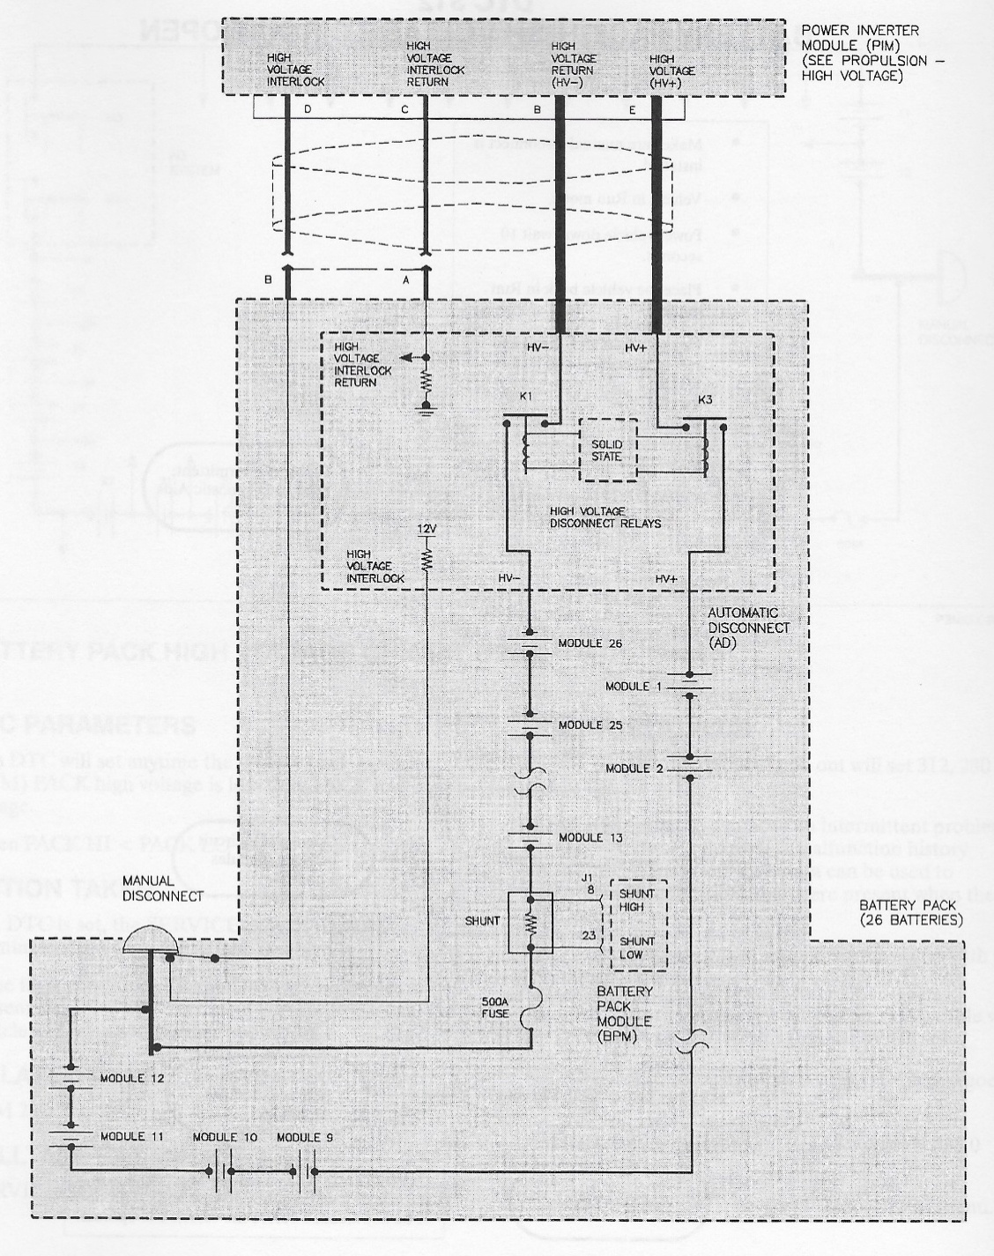
Figure 5-1 - Accumulator Schematic

Accumulator container

Accumulator Enclosure
Provide details of walls materials and thickness. If cooling openings are required provide details of how thetse openings are protected from dust and water.

Segments fixations
Describe how the segments are fixed inside the container in all 3 directions. Provide loads paths and calculations of all elements under shear or buckling stress

AIRs and fuse fixations
Provide images of how are the AIRs and the main fuse attached to the container
Figure 5-2 - Cell Connection Detail

Segments

Segment Overview
Insert a large image of the complete segment assembly. Describe segment materials and how design provides a safe environment from dropped tools.

Segment Specifications
Complete the information in the table below.
# of Segments: | 5
Cells per segment: | 15
Cell configuration in segment: | 5S3P
Energy in segment: | 2.8MJ / 0.78 kWhr
Table 5-2 - Segment Specifications

Cell Mounting
Describe how cells are mounted in the accumulator container. Provide CAD rendering or photograph to show mounting mechanism. Provide details on how cells are retained without compromising insulation and supporting isolation integrity.
Figure 5-3 - Cell Mounting in Accumulator

Cell Connections
Describe how the electrical connections are made to the cells (welded/bolted/clamped)? Define what kind of weld (resistance/laser), what kind bolt (copper w/deforming nut), material of clamp. If bus bars are used what is the cross-sectional area and ampacity?

Include CAD rendering.
Figure 5-2 - Cell Connection Detail

Maintenance Plugs
Describe how maintenance plugs are implemented in between the segments. If off the shelf components are used provide link to datasheet.
Complete the information in the table below.
Make / Model: | Connector Co. SQV436
Ampacity: | 180A
Voltage: | 750V
Datasheet: | Datasheet
Table 5-3 - Maintenance Plug Connector Specification
If custom component are used provide detailed images of them.

Describe how positive locking is provided for maintenance plugs such that they cannot unintentionally come loose.

Describe how maintenance plugs are designed such they cannot be installed or removed incorrectly.

Figure 5-4 - Maintenance Plug Locations

Temperature sensors
Provide images showing where the temperature sensors are placed and how they are in direct contact with the busbar.How many sensors are used and which percentage of cells is monitored?
Figure 5-4 - Maintenance Plug Locations

Cells

Cell Specifications
Complete the information in the table below.
Cell Make / Model / Style: | Kokam XYZ- pouch, cylindrical, or metal can
Cell nominal capacity: | 5.4 Ah
Maximum Voltage: | 4.2 V
Nominal Voltage: | 3.7V
Minimum Voltage: | 2.8V
Maximum output current: | 20C for 10s
Maximum continuous output current: | 15C
Maximum charging current: | 5C
Maximum Cell Temperature (discharging) | 65°C
Maximum Cell Temperature (charging) | 55°C
Cell chemistry: | LiFePO4
Datasheet | Datasheet
Table 5-1 - Cell Specifications

Precharge Circuit

Precharge Circuit concept
Describe your precharge circuit and how it is controlled. What is the bus capacitance? How long will it take to recharge? How does your system determine the end of the precharge process?

Precharge Circuit Component Specifications
Complete the information in the tables below.
Make / Model: | ResistorsRUs 500R01W
Resistance: | 500Ω
Voltage: | 650V
Power: | 0.1W
Power @15sec: | 1W
Datasheet | Datasheet
Table 5-4 - Precharge Resistor Specifications
Make / Model: | RelayCo ABCD876
Contact Current Rating: | 1A
Contact Voltage Rating: | 750V
Datasheet: | Datasheet
Table 5-5 - Precharge Relay Specifications
If a constant current precharge is used include schematics and datasheets of the relevant components.

Precharge Circuit Location
Provide CAD rendering(s) or photographs showing the pre-charge components. Mark the parts in the renderings, if necessary.
Figure 5-5 - Precharge Circuit Location
Explain how the power sinking elements of the precharge circuit are cooled.

BMS

BMS Specifications
Describe the BMS that has been selected. How is galvanic isolation provided between GLV and TS connections? How is isolation provided at maintenance plug boundaries? If student designed provide CAD showing that PCB spacing requirements are met for GLV/TS separation.

Voltage Monitoring
Provide details of the voltage measurement system (accuracy, acquisition frequency, …).
Describe how and where the voltage sense leads are overcurrent protected (fused). What size are the sense leads? What is their ampacity? If your sense leads are not fused please reason why and how your system detects a malfunction of one of the measurements?

Temperature Monitoring
Provide details of the temperature measurement system (accuracy, acquisition frequency, …). Give details of the temperature sensors used.

BMS Limits
Complete the table below.
Max Cell Voltage: | 6.8V
Min Cell Voltage: | 4.2V
Max Temperature: | 60°C
Min Temperature: | -5°C
Table 5-7 - BMS Setpoints

AIR

AIR Specifications
Complete the information in the table below.
Make / Model: | RelayCo DaBIG1
Contact Current: | 345A
Contact Voltage: | 350V
Datasheet: | Datasheet
Table 5-8- AIR Specifications

Accumulator Indicator

Accumulator Indicator Schematic
Provide schematic of accumulator indicator circuit. Give details of the HV supply for the LED and the activation threshold voltage. Provide specifications and links to datasheets for key components.
Figure 5-8 - Schematic of Accumulator Indication

Charging

Charger Specifications
Complete the information in the table below.
Make / Model: | ElectronPusher Inc 100V200
Power: | 0.082kW
Output Voltage: | 300V
Output Current: | 0.273A
Input Voltage: | 120V
Input Current: | 1A
Datasheet: | Datasheet
Table 5-9 - Charger Specifications
Provide images of the charger assembly and charging setup as it’ll be used during the events (include both accumulator handcart and charger assembly if they are not integrated).

Charging Shutdown Circuit
Insert a schematic of the shutdown circuit while charging. Include all required components for the charging shutdown circuit.
Figure 5-10 - Charging Shutdown Circuit Schematic

Charging TS Circuit
Insert a schematic of the TS connections when charging, show the energy path and how charging is controlled/interrupted.
Figure 5-11 - Charging TS Schematic

Charger Control
Describe how the BMS can control the charger, in particular how it can stop the charger.

Charger Demonstration
Describe numbered steps you would use to demonstrate the safe operation of charging, include how to connect, and how to disconnect. Include any safe use practices, as well as what to look for proper operation vs. a faulted condition.

Motor controller

Motor controller 1

Description, type, operation parameters
Describe important functions, provide table with main parameters like resulting voltages->minimum, maximum, nominal, currents etc.
Fill out the following table:
Motor controller type: | ABC Controller
Maximum continous power: | 60kW
Maximum peak power: | 75kW for 10s
Maximum Input voltage: | 600VDC
Output voltage: | 250VAC
Maximum continuous output current: | 100A
Maximum peak current: | 200A for 5s
Control method: | PWM, analog signal...
Cooling method: | Air, water, oil...
Auxiliary supply voltage: | 24VDC
Table 5.1 General motor controller data

Wiring, cables, current calculations, connectors
Describe the wiring, show schematics, provide calculations for currents and voltages and show data regarding the cables and connectors used.
Additionally fill out table:
Wire type: | Company A, 0.205 mm²
Current rating: | 150A
Maximum operating voltage: | 800V
Temperature rating: | 150 °C

Position in car
Provide CAD-renderings showing the relevant parts. Mark the parts in the rendering, if necessary.

Motor controller 2
…
If identical parts are used, just refer to the corresponding sections, don’t copy and paste.

Motors

Motor 1

Description, type, operating parameters
Describe the motor used, provide table with main parameters like resulting voltages->minimum, maximum, nominal, currents, resulting motor power, use figures to show important characteristics. Describe the casing and if the casing rotates the finger guards used.
Additionally fill out table:
Motor Manufacturer and Type: | ABC Motor
Motor principle | Asynchronous, permanently excitated
Maximum continuous power: | 25kW
Peak power: | 70kW for 5s
Input voltage: | 250VAC
Nominal current: | 50A
Peak current: | 70A
Maximum torque: | 60Nm
Nominal torque: | 20Nm
Cooling method: | Water, oil, air,...
Table 6.1 General motor data
Give a plot of power vs. Rpm including a line for nominal and maximum power
give a plot of torque vs rpm including a line for nominal and maximum torque

Wiring, cables, current calculations, connectors
Describe the wiring, show schematics, provide calculations for currents and voltages and show data regarding the cables and connectors used.

Position in car
Provide CAD-renderings showing all relevant parts. Mark the parts in the rendering, if necessary and clearly identify the structure used to protect all relevant parts.

Motor 2
…
If identical parts are used, just refer to the corresponding sections, don’t copy and paste.

Torque encoder

Description/additional circuitry
Describe the type of the torque encoder(s) used, provide tables with main operation parameters, and describe additional circuitry used to check or manipulate the signal going to the motor controller. Describe how the system reacts if an implausibility or error (eg. short circuit or open circuit or equivalent) is detected.
Torque encoder manufacturer and type: | ABC Encoder
Torque encoder principle: | potentiometer
Supply voltage: | 5V
Maximum supply current: | 20mA
Operating temperature: | -20..180 °C
Used output: | 0-5V
Table 7.1 Torque encoder data

Wiring
Describe the wiring, show schematics, show data regarding the cables and connectors used.

Position in car/mechanical fastening/mechanical connection
Provide CAD-renderings showing all relevant parts and discuss the mechanical connection of the sensors to the pedal assembly. Mark the parts in the rendering, if necessary.

Other Items

LV part 1
Describe those parts here which interfere or influence the tractive system, for example a controlling unit that measures wheel speeds and steering angle and calculates a target torque for each motor or a DC/DC-Converter providing power for the LV-system from the HV-system, etc.

Description
Describe the parts used and their circuitry, and provide main operation parameters, use tables or figures, etc.

Wiring, cables,
Describe the wiring, show schematics, etc.

Position in car
Provide CAD-renderings showing the relevant parts. Mark the parts in the rendering, if necessary.

LV part 2

Energy Meter

Energy Meter Location
Provide CAD rendering(s) or photographs showing the energy meter location and the download connector location. Mark the parts in the renderings, if necessary.
Figure 7-1 - Energy Meter Location

Energy Meter GLV Supply
Describe how the Energy meter GLV power is supplied.

Energy Meter HV Sense
Describe how the Accumulator Voltage is sensed by Energy meter. Include fusing, wire gage, terminals used.

Firewall

Firewall Layer Specifications
Complete the information in the table below.
Aluminum layer thickness: | 0.2mm
Insulating layer thickness: | 2mm
Insulating Material Make / Model: | Conductive Co. FLDPRDCT
Insulating Material Datasheet: | Datasheet
Insulating layer side: | Driver
Table 7-1 - Firewall Specifications

Firewall Location
Provide CAD rendering(s) or photographs showing the firewall components. Mark the parts in the renderings, if necessary.
Figure 7-2 - Firewall Location

Grounding

Composite Grounding
Describe how any composites will be grounded to meet the required grounding level.

Other Components
Add additional sections here to discuss other unique aspects of your design that you feel are appropriate for the ESF. For example, DCDC converters, details of team designed motor controller or battery chargers, etc.

Appendix

SDS (MSDS) of accumulator cell
Insert SDS for accumulator cells here.

